**FOR IMMEDIATE RELEASE**

**June 19, 2012**

**New report measures health of Capital-area communities**

Health leaders from across the region today unveiled a first-of-its-kind report that measures the health of communities in Clinton, Eaton and Ingham counties.

The 2012 Community Health Profile and Health Needs Assessment is packed with important data, including maps on the spread of health problems in the region.

The report measures factors that go beyond health care and dives into what causes people to be healthy (or not) in the first place.

This report is the first step in a comprehensive health improvement effort that spans three counties, four hospital systems, and a myriad of community members and organizations.

“Once we identify those priority health needs, we will develop a plan to improve health across the whole community where we live, work, learn and play,” said Anne Barna, Project Coordinator.

The next step in the process is to hear from people in the community – the group is hosting seven community dialogues around Clinton, Eaton, and Ingham counties.

“Over the next month, the public will be invited to examine the report and take part in discussions at various community dialogues,” Barna said. “Together we will decide what issues are most affecting health in our area, and develop an action plan for improvement.”

Healthy! Capital Counties was developed in response to a new mandate under the federal health care reform law to conduct a community health needs assessment every three years beginning in 2012. Local health organizations have traditionally conducted these kinds of assessments individually.

“Instead of working independently of each other, it made more sense to work together to save time and money, and to be able to have the greatest impact,” Barna said.

The initiative is funded by each of the participants as well as through a Demonstration Site grant from the National Association of County and City Health Officials through funding from the Robert Wood Johnson Foundation.

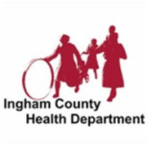

**Barry-Eaton District**

**Health Department**

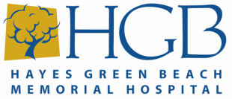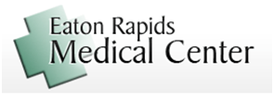

MID-MICHIGAN District Health Department

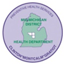

Find more information about Healthy! Capital Counties at [www.healthycapitalcounties.org](http://www.healthycapitalcounties.org). The public may sign up to attend a community dialogue in their area or to view the report by visiting the website.

MEDIA Contact:

*Hayes Green Beach Memorial Hospital: Darice Darling (517) 541-5831*

*McLaren Greater Lansing Hospital: Brian Brown (517) 975-7107*

*Sparrow Health System: John Foren (517) 364-2207*

*Eaton Rapids Medical Center: Lindsay Stevenson (517) 663-9524*

*Barry-Eaton District Health Dept: Anne Barna (517) 541-2694*



**Barry-Eaton District**

**Health Department**



MID-MICHIGAN District Health Department

