**Wednesday, May 2nd, 2012 9:00am**

**Area health organizations create consortium to improve health in Clinton, Eaton and Ingham Counties**

Local health departments and hospitals are joining forces to measure the community’s health through Healthy! Capital Counties, an initiative to improve the health and well-being of residents in Clinton, Eaton and Ingham Counties.

Community leaders from the Ingham County Health Department, Barry-Eaton District Health Department, Mid-Michigan District Health Department, along with Sparrow Health System, McLaren-Greater Lansing, Hayes Green Beach Memorial Hospital and Eaton Rapids Medical Center are working together to identify how healthy residents are in the tri-county area, what health conditions are prevalent and the root causes of those health problems.

“Once we identify those priority health needs, we will develop a plan to improve health across the whole community where we live, work, learn and play,” said Anne Barna, Project Coordinator.

The consortium is looking at surveys, vital records, and program and facility data, and conducted eight focus groups throughout the three counties. The results of the research will be published in the Community Health Profile Report in mid-May. The public report will offer detailed data on the health needs and concerns of residents in Ingham, Eaton and Clinton counties, including medically underserved people.

“In June, the public will be invited to examine the report and take part in discussions at various community dialogues,” said Ms. Barna. “Together we will decide what is most important and develop an action plan for improvement.”

Healthy! Capital Counties was developed in answer to a new mandate under the health reform law to conduct a community health needs assessment every three years beginning in 2012. Local health organizations have traditionally conducted these kinds of assessments individually.

“Instead of working independently of each other, it made more sense to work together to save time and money, and to be able to have the greatest impact on our community,” said Ms. Barna.

The initiative is funded by each of the participants as well as through a Demonstration Site grant from the National Association of County and City Health Officials through funding from the Robert Wood Johnson Foundation.

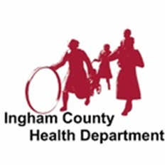

**Barry-Eaton District**

**Health Department**

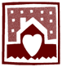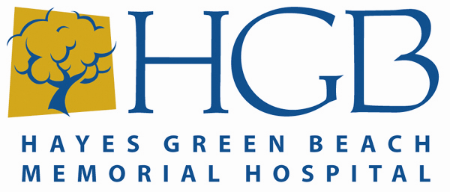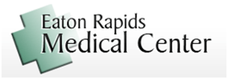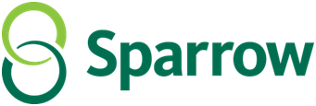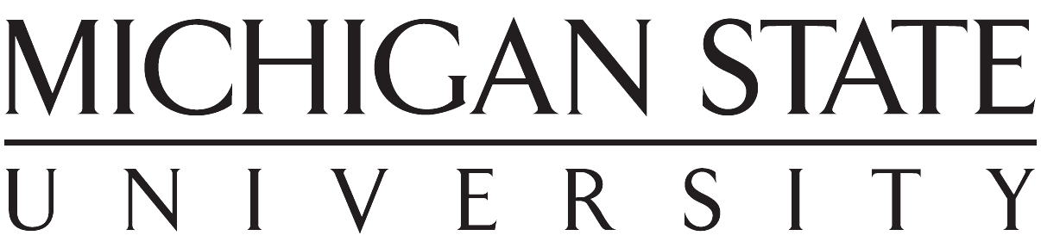

MID-MICHIGAN District Health Department

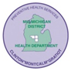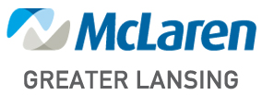

Find more information about Healthy! Capital Counties at [www.healthycapitalcounties.org](http://www.healthycapitalcounties.org). The public may sign up to find out about a community meeting in their area, or to view the report by visiting the website.

MEDIA Contact:

*Hayes Green Beach Memorial Hospital: Darice Darling (517) 541-5831*

*McLaren Greater Lansing Hospital: Brian Brown (517) 975-7107*

*Sparrow Health System: John Foren (517) 364-2207*

*Eaton Rapids Medical Center: Lindsay Stevenson (517) 663-9524*

*Barry-Eaton District Health Dept: Anne Barna (517) 541-2694*



**Barry-Eaton District**

**Health Department**



MID-MICHIGAN District Health Department

